TMT/EENES INDUSTRIES/S0445/2025 28-08-2025

To,
B.G RAMLINGESH,
EENES INDUSTRIES,
MOBILE : 9845705212,
KARNATAKA -58115.

Dear Sir,

Sub: - Supply of Three Roller Plate Bending machine width Hydraulic Pre-Pinching

We thank you for your inquiry regarding Plate Bending machine for MS plate width 3000 mm and thickness 30 mm. We are glad to inform you that we would be in a position to do the required equipment. Given below are the specifications and description of the machine and our terms and conditions.

S No | Description of the unit | Offer
1. | Three Roller Plate Bending machine for bending capacity, width 3000 and thickness 30 mm along with cone bending facility and along with complete electrical. | Rs 48,00,000/- (Rupees Forty-Eight Lakhs Only)

Specifications of the equipment

1) Maximum width of the plate that can be rolled : 3000 MM

2) Maximum thickness of the plate that can be rolled : 30 MM

3) Top Roll diameter : 430 MM

4) Bottom Roller Diameter : 380 MM

5) Minimum Rolling Diameter : 880 MM

6) Rolling speed : 2.2 RPM

7) Maximum yield limit of the plate : 235 Mpa.

8) Total power : 50.2 HP

Hydraulic power pack : 30 Hp
Load motors : 10 Hp -2 nos
Lubrication pump: 0.2 HP

GENERAL TERMS & CONDITIONS:

- Price quoted per unit ex-work. Hyderabad.
- Following charges are additional to your account.
- Freight Charge : As actual to be borne by you.
- Excise : Extra As Applicable
- Sales Tax : 18% GST
- Packing charge : As actual to be borne by you.
- Insurance : As actual to be borne by you.
- Payment : 50% advance along with order balance before delivery but after inspection at our works.
- Delivery : With 50% advance 4 months
- Validity : One month from the date of submission.
- Inspection : Inspection at our works prior to dispatch.
- Warranty : The machine is warranted for a period of 12 months from the date of dispatch against any manufacturing defects/ faulty material or bad workmanship of any part or component but not against any kind of abnormal or improper use of machine. Defective part or component will be replaced or repaired free of cost. Electrical components are outside the scope of this warranty.
- Commissioning : Erection & commissioning done by you, but required technical support & guidance provide by us at additional cost.

NOTE:
- Oil is not in scope of our supply.
- Raw material for trial is to be arranged by you at your cost.

We are sure you will find our offer in line with your requirements. For further clarifications if any, please contact T.Sivaramakrishna, 9849207176 / 9246221106. Email: srktalam@gmail.com
Thanking you and assuring you of our best services.

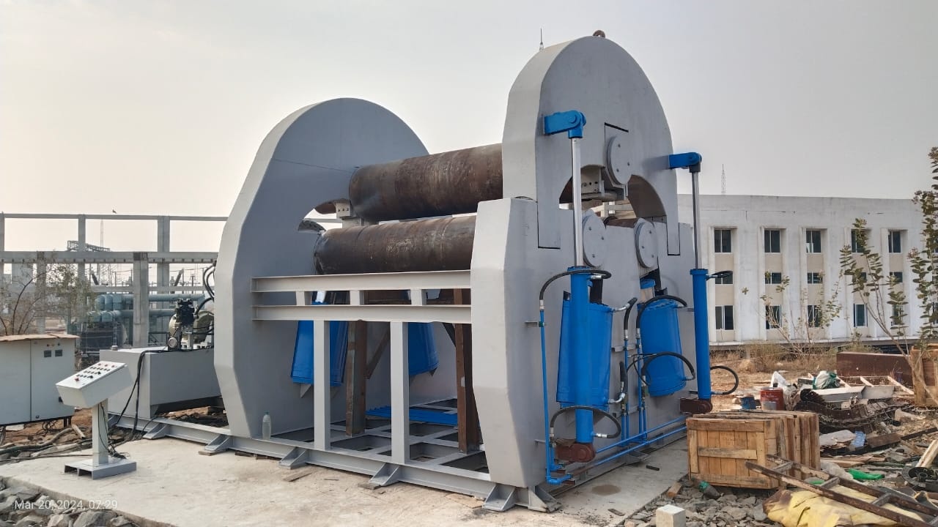

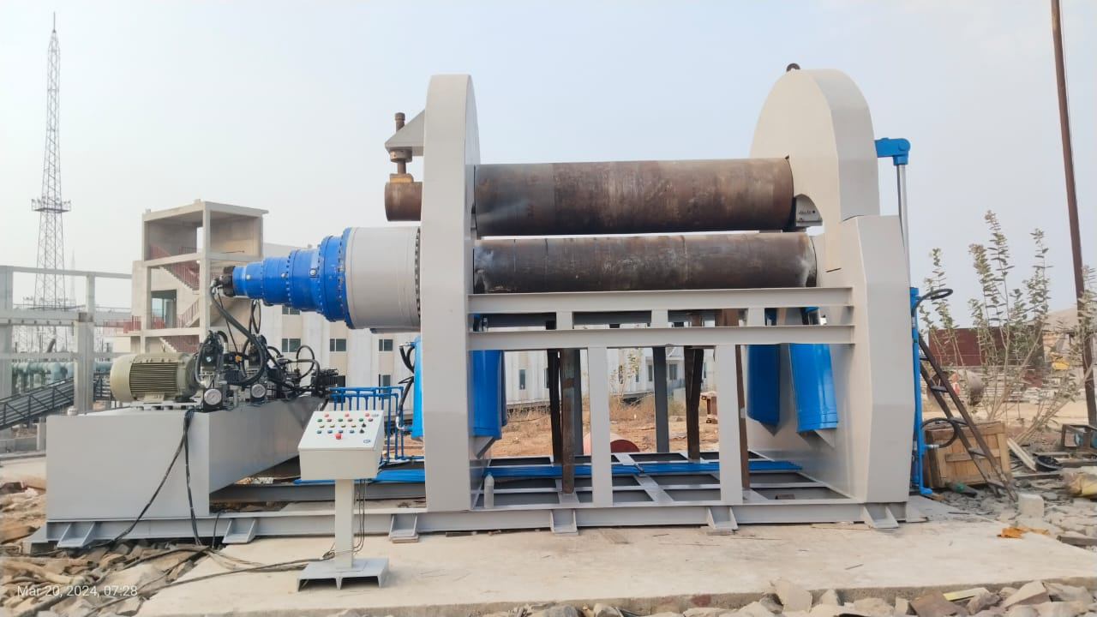

For TECHNO MACHINE TOOLS

( T. SIVARAMAKRISHNA)

